**UNIT TESTING**

* CUnit is a lightweight system for writing, administering, and running unit tests in C.
* It provides C programmers a basic testing functionality with a flexible variety of user interfaces.
* CUnit is built as a static library which is linked with the user's testing code. It uses a simple framework for building test structures, and provides a rich set of assertions for testing common data types.

1. For writetofile function:

Test_Case 1-6

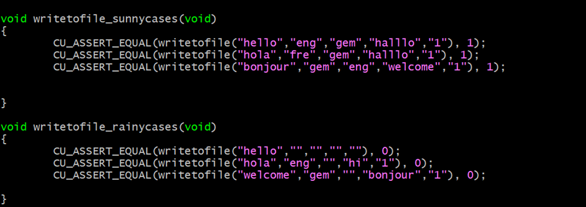

1. For modify() function

Test_Case 7-12

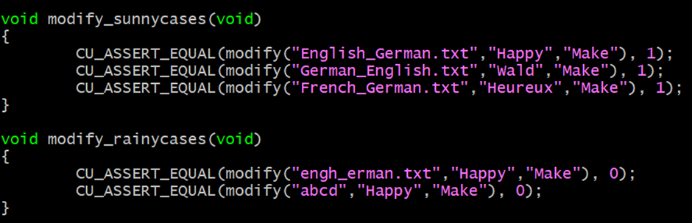

3.For delete() function

Test_Case 13-18

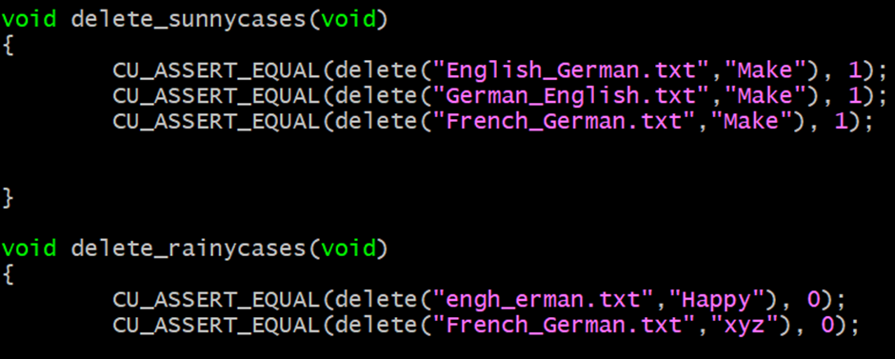

4.For translate() function

Test_Case 19-25

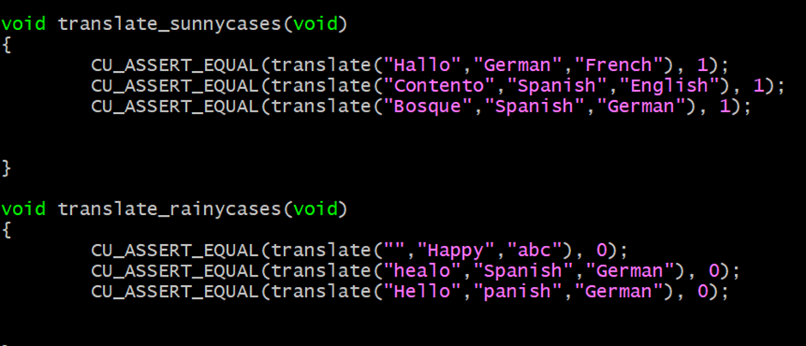

**Output:**

